Spiral Stairs HowTo

Table of contents

General: 3

Change CenterPillar options: 3

Create Staircase: 3

Pause Stair Creation: 3

Show Center Pillar: 3

Stairs Setup: 4

Stairs Collider: 4

Angled Stair Collider: 4

Stairs Rigidbody: 4

Stairs Gravity: 4

Stairs Kinematic: 5

Amount of Stairs: 5

Stairs CCW: 5

Stairs Go Up: 5

Start Position Angle: 5

Current Angle: 5

Total Angle: 5

Move Stair Inside Pillar: 6

Stair Size: 6

Vertical Range Between: 7

XScale Speed: 7

XScale Instant: 7

YScale Speed: 7

YScale Instant: 7

ZScale Speed: 7

ZScale Instant: 7

Stair Material: 7

Panel Setup: 8

Create Panel: 8

Create Panel Front Mesh: 8

Panel Collider: 9

Panel Rigidbody: 9

Panel Gravity: 9

Panel Kinematic: 9

Panel Size: 9

Stair Panel Material: 9

Panel Front Mesh Material: 9

Railing Setup: 10

Create Railing: 10

Railing Collider: 10

Railing Rigidbody: 10

Railing Gravity: 10

Railing Kinematic: 10

Handle Collider: 10

Handle Rigidbody: 10

Handle Gravity: 11

Handle Kinematic: 11

Rail Height: 11

Railing Scale Speed: 11

Railing Scale Instant: 11

Railing Material: 11

Rail Handle Material: 11

General (continues): 12

Show Gizmos: 12

Gizmo Color: 12

Gizmo Size: 12

# General:

### Change CenterPillar options:

When you want to change CenterPillar position or scale you should do this straight from this object. Material for CenterPillar is also given straight from this object.

When you move CenterPillar you should remember that this object is a child object of StairsSpiral object and when you move this, the parent object will also move so you should first move this object to the wanted position and then move the StairsSpiral to the correct position.

### Create Staircase:



This will start the creation of the stairs when enabled. If unchecked it will still create one set of staircase and if enabled again it will create second set of stairs, but with the current angle, that was changed while in the first creation, so you should change current angle to what suits you best if you need two set of stairs in one pillar.

### Pause Stair Creation:



Enabling this option will halt the creation of the stairs at any given moment, changing stair z-axis animation on and to 0. Disabling this will continue stair creation and change z-axis animation values back to what they were before.

### Show Center Pillar:



Disabling this option will disable CenterPillar Mesh Renderer, actively hiding CenterPillar. This will also destroy Collider’s from CenterPillar and StairPillar. One example what you could do with this, would be to create stairs for example to some tower that does not have stairs. Let’s say player stands next to tower that has no stairs and when he does something stairs will be created dynamically the tower. What you need to do in a case like this is to hide CenterPillar and set CenterPillar scale same as the tower and this way stairs will be created in the outside wall of the tower, although tower should be round shape or stairs will look bit weird.

# Stairs Setup:

### Stairs Collider:



This is a normal Box Collider that will be put to every stair created if you enable the option.

If you enable Angled Stair Collider you might not need these and without this you will get less collider’s in your scene.

### Angled Stair Collider:



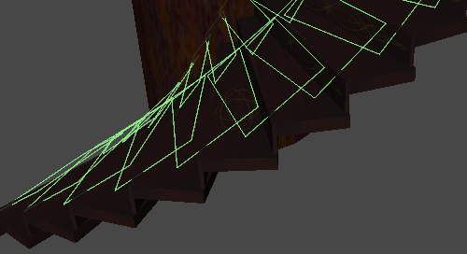

With this option enabled, two collider’s are created on top of every stair, angled in the height angle of the stairs. Idea behind these collider’s is that if you have problems going up with your character controller this will help out. There is also the added bonus of less “head popping” action while going up stairs, although if you don’t need these just disable and use normal stair collider’s since it will save you 1 collider per stair.

### Stairs Rigidbody:



Stairs will be created with Rigidbody component if enabled.

### Stairs Gravity:



If stairs are created with Rigidbody, enabling this will enable the Gravity option on the Rigidbody component.

Angular Drag is also set to 0 and mass is the default 1.

### Stairs Kinematic:



If stairs are created with Rigidbody, enabling this will enable the Kinematic option on the Rigidbody component.

### Amount of Stairs:



Here you can decide amount of stairs that are going to be created. This will also affect Railing and Railing Handle if because there is always same amount of each.

### Stairs CCW:



Are the stairs going to be created clockwise or counterclockwise.

### Stairs Go Up:



Direction of the stairs so that the stairs go up or down. When you disable the option it will change values to negative for Stair Size y-axis and Vertical Range Between.

### Start Position Angle:



Set starting positions for stairs around the CenterPillar. Amount here is 180 and that means center right side of the CenterPillar.

### Current Angle:



This shows the current angle for stair while creating them. If you enable Create Staircase option after one set of stairs is created it will create next set of stairs according to this value but will start on same height as the first set of stairs.

### Total Angle:



How many times will the stairs go around the CenterPillar. If you would choose 360 then stairs would go once around the pillar from the starting position.

### Move Stair Inside Pillar:



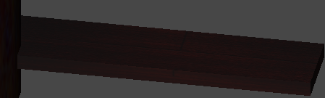



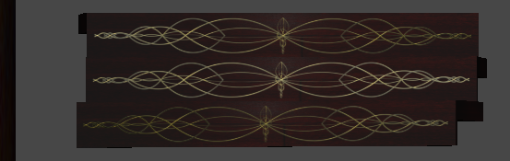

Move the place where stairs are created in. This value will move the stair closer to the center of the CenterPillar slightly. Positive values will move closer to the middle and negative values move stairs further from the center out as far as you like.

### Stair Size:



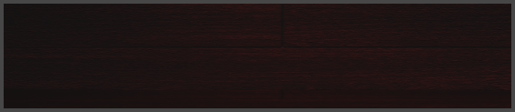



With this option you can give the size you like to the stair. Top picture shows X-axiz (width horizontal arrow) and z-axis (depth vertical arrow). Picture on the bottom show Y-axis (height vertical arrow).

### Vertical Range Between:



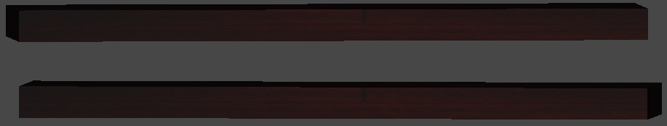

If you want some room between the stairs this is the correct place.

### XScale Speed:



Set stair width animation speed.

### XScale Instant:



When you don’t want any width animation to the stair creation, enable this.

### YScale Speed:



Set stair height animation speed.

### YScale Instant:



When you don’t want any height animation to the stair creation, enable this.

### ZScale Speed:



Set stair depth animation speed.

### ZScale Instant:



When you don’t want any depth animation to the stair creation, enable this.

### Stair Material:



Material set in here will be used by all stairs. There are different material components you can set for CenterPillar, Stair Panel, Stair Panel Frontmesh, Railing and Railing Handle.

# Panel Setup:

### Create Panel:



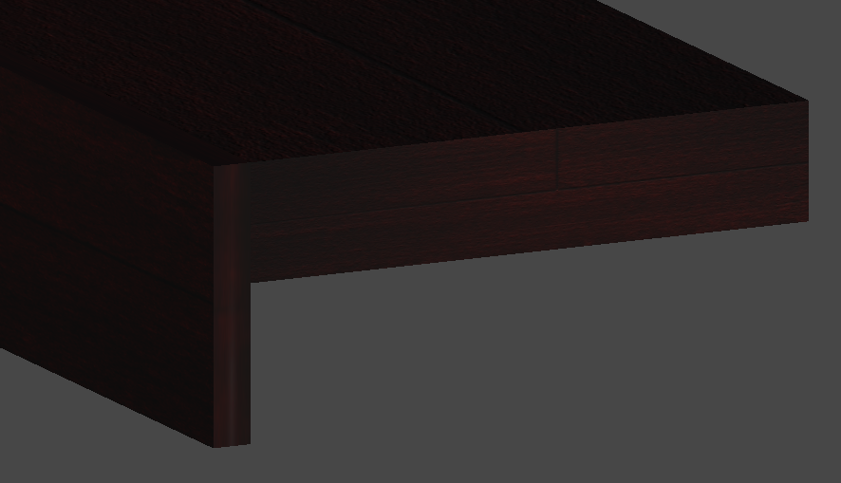

Create Panel creates a panel in front of the stair. This option will give your stairs some extra flair if you use different material from stairs. If you don’t need panel for the stair but want a little more flair then you can also disable panel but use front mesh so the front facing side has a different look but without a panel you will reduce the amount of draw calls and memory.

### Create Panel Front Mesh:



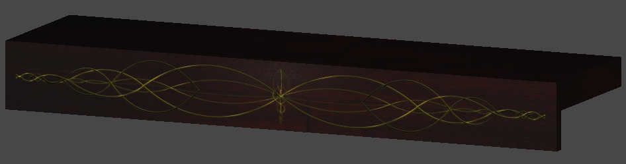

In the case where stair panel is not enough and you want different look for the forward facing side of the panel. Remember that you can use Front Mesh even without the panel. Mesh doesn’t have size option, because it will always be the height of the panel or the size of the stair if no panel was created. Mesh position is automatically calculated according to size of the panel or if no panel was created. In this picture the mesh is transparent mesh where you can see the texture of the panel through the golden figure.

### Panel Collider:



When you want colliders for the panels enable the option. Normally I would disable this option to conserve computing power.

### Panel Rigidbody:



Add Rigidbody component to the panel.

### Panel Gravity:



If Panel has Rigidbody enable or disable Gravity option.

### Panel Kinematic:



If Panel has Rigidbody enable or disable Kinematic option.

### Panel Size:



Set size for the panel. This option works the same as stairs Start Scale. Remember if you change the size of the stair you should also change the size of the panel, although this mostly is needed with width of the stair.

### Stair Panel Material:



Set material for the panel.

### Panel Front Mesh Material:



Set material for the front mesh. In my honest opinion transparent materials give the best presentation with this.

# Railing Setup:

### Create Railing:

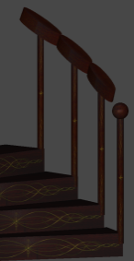

Picture on the right shows railing with railing handles. With this option you will decide if you want to create both railing and handle. First handle is always a sphere and rest of the handles is type cylinder.

### Railing Collider:



When you want colliders for the railing enable the option. Normally I would disable this option to conserve computing power and use colliders on the handles. When you have colliders only on the handles be sure that railing is not too high and player can run under the handle.

### Railing Rigidbody:



Add Rigidbody component to the railing.

### Railing Gravity:



If railing has Rigidbody enable or disable Gravity option.

### Railing Kinematic:



If railing has Rigidbody enable or disable Kinematic option.

### Handle Collider:



When you want colliders for the handles enable the option. Normally I would use this collider; set railing collider to false and make sure railing is not high enough to go under.

### Handle Rigidbody:



Add Rigidbody component to the handle.

### Handle Gravity:



If handle has Rigidbody enable or disable Gravity option.

### Handle Kinematic:



If handle has Rigidbody enable or disable Kinematic option.

### Rail Height:



Give desired height for the railings. Handles go on top of the railing.

### Railing Scale Speed:



Set animation speed for the railing.

### Railing Scale Instant:



If you don’t need any animation for the railing you should enable this option. One reason for this is when you want to keep the value set in the scale speed option.

### Railing Material:



Set material for the railing.

### Rail Handle Material:



Set material for the handles.

# General (continues):

## Show Gizmos:

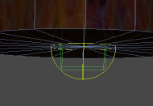With this selection you can change if Gizmos are shown or not.



## Gizmo Color:

Color of the gizmo’s (shown in the picture).

## Gizmo Size:

Size of the gizmo’s (shown in the picture).